c.a.s.e. inc mentoring grants 2023 - application form
We have designed this form to help you develop realistic goals and expectations and crystalise your potential direction within a mentoring experience. Some questions should be considered before you approach a potential mentor, and others can be addressed together with your proposed mentor.
Having clarity on what you wish to achieve from the mentoring will increase the likelihood of succeeding.
Please answer the questions in the space provided. Dot points are acceptable.
Applicant’s name:
email:
phone:
address:

In 200 words or less, tell us about your current art practice.

Questions to consider when choosing a mentor | Responses
What areas of your practice do you wish to develop within the 9-month timeframe? Consider what you might want to change about your existing practice and/or the skills you want to develop.
How do you see a mentor helping you with this?
How often & for how long each time do you hope to meet with a mentor? How will you negotiate this?
How and where do you want to meet?
In person? - online? - their studio? – your studio? - mixture?
What key questions do you have for a mentor to begin the direction and process you wish to go in?
What boundaries will you establish in your mentoring relationship? e.g., how much time is doable, what activities will be shared …
Who have you chosen to be your mentor?
What is their practice/area of expertise?
What relationship have you had with the chosen mentor - a former teacher, colleague ...? If, none how did you hear about this person and their expertise?
Why did you choose your mentor?
How will their mentoring help you move your career forward?
How, where, and when do you propose to structure the meetings? How do you propose to set an agenda that will be beneficial for both of you?
Has an agreement been made about expectations after the final mentoring session - do you expect ongoing communication from the mentor? Is that reasonable for both parties?
How will you measure the goals and objectives you set for the mentoring - what does success look like?

Once complete please email tis form with your submission to casegrants2023@gmail.com.
Label each attached doc or image with your name followed by the doc/image title.
Closing Date: Sunday 9th July 2023

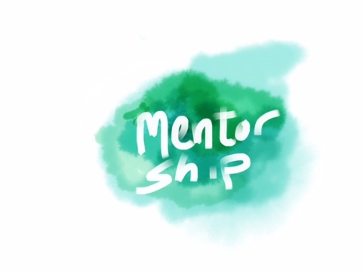
What to submit checklist:
- Completed Application worksheet.
- Completed and signed T&C document.
- Outline of proposed mentoring sessions (where, how, & when)
- 3 x jpegs of your work
- 1-page cv

