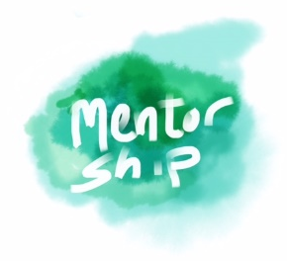
2023 c.a.s.e. mentoring grant
terms & conditions

For the proposed mentor and mentee to complete. Please submit this to c.a.s.e. with your application.

I ………………………………………………………………………... (proposed mentor’s name) agree to mentor the recipient of the c.a.s.e mentoring grant ……………………………………………………………... (proposed mentee’s name) for a total time of ………… hours at $……...... per hour (up to $600 in total). The mentor sessions will occur within 9 months of a successful grant notification. I understand the mentoring will be dependent on the mentee being approved for the grant by c.a.s.e.

I ………………………………………………………………………... (proposed mentee’s name), under the 2023 c.a.s.e. mentoring grant programme, agree to be mentored by …………………………………….……………… (proposed mentor’s name) for a total time of ………… hours at $……...... per hour (up to $600 in total). The mentor sessions will occur within 9 months of the successful grant notification.

We understand that the specific details of where, how, and when the sessions will be held will be worked out between the proposed mentor and mentee. It will include a minimum of two mentoring sessions, with a period between sessions to allow the recipient to practice what has been covered.

We understand that at the conclusion of the mentorship experience, the mentee is required to provide an acquittal report to c.a.s.e. that will include photos, and these photos may be used in c.a.s.e. promotional material.

We understand that on completion of the mentoring, a fee of up to $600 will be paid directly to the mentor, upon receipt of an invoice emailed to c.a.s.e for the mentoring service provided.

Signed Mentor ……………………………….…………………… Date ...… /…... / 2023

Contact email: …………………………….……….……………. Contact phone: ……………………………....

Signed Mentee ……………………………….…………………… Date ...… /…... / 2023

Contact email: …………………………….……….……………. Contact phone: ……………………………....

